

Tech Saksham

Capstone Project Report

ARTIFICIAL INTELLIGENCE AND MACHINE LEARNING FUNDAMENTALS

**“AGRICULTURAL RAW MATERIAL ANALAYSIS (SOIL ANALYASIS FOR CROPS)”**

**“COLLEGE OF ENGINEERING GUINDY”**

|  |  |
| --- | --- |
| **NM ID** | **NAME** |
| au2021109014 | JAGAN C |

|  |
| --- |
| Trainer Name |
| Master Trainer  RAMAR |

**ABSTRACT**

In agriculture sector where farmers and agribusinesses have to make innumerable decisions every day and intricate complexities involves the various factors influencing them. An essential issue for agricultural planning intention is the accurate yield estimation for the numerous crops involved in the planning. Data mining techniques are necessary approach for accomplishing practical and effective solutions for this problem. Agriculture has been an obvious target for big data. Environmental conditions, variability in soil, input levels, combinations and commodity prices have made it all the more relevant for farmers to use information and get help to make critical farming decisions. This paper focuses on the analysis of the agriculture data and finding optimal parameters to maximize the crop production using data mining techniques like PAM, CLARA, DBSCAN and Multiple Linear Regression. Mining the large amount of existing crop, soil and climatic data, and analysing new, non-experimental data optimizes the production and makes agriculture more resilient to climatic change.

**INDEX**

|  |  |  |
| --- | --- | --- |
| **Sr. No.** | **Table of Contents** | **Page No.** |
| 1 | Chapter 1: Introduction | 1 |
| 2 | Chapter 2: Services and Tools Required | 3 |
| 3 | Chapter 3: Project Architecture | 4 |
| 4 | Chapter 4: Project Outcome | 7 |
| 5 | Conclusion | 8 |
| 6 | Future Scope | 9 |
| 7 | References | 10 |
| 8 | Code | 13 |

**CHAPTER 1 INTRODUCTION**

# Problem Statement

The need for specialized tools to create, analyze, and present meteorological data

in the form of maps and charts. These tools are crucial for meteorologists, researchers, and the

general public to understand complex weather patterns quickly and make informed decisions.

Weather map software plays a vital role in forecasting, tracking severe weather events, and

providing insights into atmospheric conditions. By offering clear visual representations of

weather data, these tools contribute to public safety by enabling timely warnings, emergency

responses, and proactive planning for various weather conditions. Additionally, weather maps

incorporate various components such as weather graphics, landscape mapping, pressure areas,

and wind visualization to convey a wealth of meteorological information effectively. The goal

is to bridge the gap between intricate meteorological models and user-friendly visualizations to

enhance understanding and decision-making in the field of meteorology.

# Proposed Solution

The use of specialized software tools that can effectively present meteorological data in the form of maps and charts. These tools help meteorologists, researchers, and the general public understand complex weather patterns quickly and make informed decisions.

SmartMet is a tool that allows forecasters to make updates to numerical weather model output based on meteorologist expertise and available observations. It ensures the best quality for edited data, weather forecasts, and products, making it an effective tool for improving or changing model data

# Feature

Visual Representation of Meteorological Data

Creation of High-Quality Maps

Access to Weather and Climate Web Service

Customization and Tailored Forecasting

* 1. **Advantages**

**:**

**.**

Awareness and Education

Forecast Evaluation

Risk Mitigation

Decision Support

Enhanced Understanding

# Scope

Agriculture and Food Security: Visualizing weather data is essential for optimizing agricultural practices, enhancing crop yield prediction, and mitigating risks associated with adverse weather conditions. The scope includes monitoring weather patterns, assessing climate suitability for crops, and supporting decision-making processes for farmers, agronomists, and policymakers to ensure food security and sustainable agriculture.

Meteorology and Weather Forecasting: Weather data visualization plays a crucial role in meteorology and weather forecasting by providing meteorologists with tools to analyze, interpret, and communicate weather information effectively. The scope encompasses visualizing observational data, numerical weather model outputs, satellite imagery, radar data, and other meteorological datasets to generate accurate forecasts and warnings for weather-related hazards.

# Future Work

Integration of Big Data and Machine Learning: Leveraging big data analytics and machine learning techniques can enhance weather data visualization by enabling the analysis of large and complex datasets. Future research could focus on developing advanced algorithms for pattern recognition, anomaly detection, and predictive modeling to extract actionable insights from massive volumes of weather data.

**CHAPTER 2**

**SERVICES AND TOOLS REQUIRED**

# Services Used

**Weather APIs** (Application Programming Interfaces) provide developers with access to weather data from various sources, including government agencies, meteorological organizations, and private weather providers.

**Weather dashboard platforms** offer customizable dashboards and widgets for visualizing weather data in real-time. These platforms typically provide pre- built templates, drag-and-drop interfaces, and interactive components for displaying weather forecasts, radar maps, satellite imagery, and other weather- related information.

# Tools and Software used

**Tableau** is a powerful data visualization tool that allows users to create interactive and visually appealing visualizations from various data sources, including weather data. It offers a user-friendly interface with drag-and-drop functionality, making it easy to create dashboards, charts, maps, and other visualizations.

**ArcGIS** is a geographic information system (GIS) software platform developed by Esri, widely used for mapping and spatial analysis. It provides powerful tools for visualizing, analyzing, and interpreting spatial data, including weather data.

In the beginning, the workspace containing the following information is set up for every GRASS GIS session:

* Location - defines the projection, default spatial extent, and resolution for all data in the project;
* Mapset - defines collections of data within a given location. Mapsets can be used to organize data of similar types or categories

Database - defines where in the file system the files for the GIS will be stored for the given location and mapset.

**CHAPTER 3**

**PROJECT ARCHITECTURE**

# 3.1 Architecture

**USER FRONTEND BACKEND**



|  |  |  |
| --- | --- | --- |
|  | **HTML 5** | **NODEJS 14.0**  **Database** |

# 1Data Sources:

Meteorological Stations: Traditional weather stations that collect data such as temperature, humidity, pressure, wind speed, and precipitation.

Satellite Imagery: Remote sensing satellites capture images and data about cloud cover, sea surface temperature, and other atmospheric conditions.

Radar Systems: Doppler radar systems provide real-time information about precipitation intensity and movement.

Weather APIs: Access to third-party weather APIs for obtaining forecast data, historical weather information, and specialized meteorological data.

# Data Ingestion and Processing:

Data Ingestion Layer: Responsible for collecting data from various sources in real-time or at regular intervals.

Data Cleaning and Preprocessing: Processes to clean, validate, and preprocess raw data to ensure consistency and accuracy.

Data Storage: Storage infrastructure (such as databases or data lakes) to store processed weather data efficiently.

# Data Analysis and Modeling:

Statistical Analysis Basic statistical techniques to analyze historical weather data and identify patterns or trends.

Machine Learning Models: Developing and training machine learning models for weather forecasting, anomaly detection, or predictive analytics.

Visualization-Driven Analysis: Techniques to perform exploratory data analysis (EDA) and derive insights from the data through visualization.

# Visualization Layer:

Dashboard Interface: Interactive dashboards that display real-time weather information, forecasts, and historical data.

Geospatial Visualization: Maps and geographic information system (GIS) tools for visualizing spatial weather data, such as temperature maps or precipitation patterns.

Time-Series Visualization: Graphs and charts to visualize temporal trends in weather variables over different time periods.

Customizable Widgets: Widgets or modules that allow users to customize their visualization preferences and select specific weather parameters of interest.

# User Interaction and Engagement:

-User Authentication and Authorization: Secure user authentication mechanisms to control access to the visualization platform.

Feedback Mechanisms: Channels for users to provide feedback, report issues, or suggest improvements to the visualization interface.

Collaboration Features: Tools for users to share visualizations, collaborate on analysis, or communicate with other users within the platform.

# 6Integration and Deployment:

API Integration: Integration with external APIs or data sources to enhance the richness of weather data available for visualization.

Scalability and Performance: Ensuring the architecture is scalable to handle large volumes of data and can deliver responsive performance.

-Deployment Environment: Deployment of the visualization platform on cloud infrastructure or on-premises servers, considering factors such as reliability, availability, and scalability.

# Monitoring and Maintenance:

Logging and Monitoring: Logging mechanisms to track system activities, errors, and performance metrics.

Automated Alerts: Alerts and notifications to alert administrators about system issues or anomalies.

- Regular Maintenance: Scheduled maintenance tasks, updates, and patches to ensure the stability and security of the visualization platform.

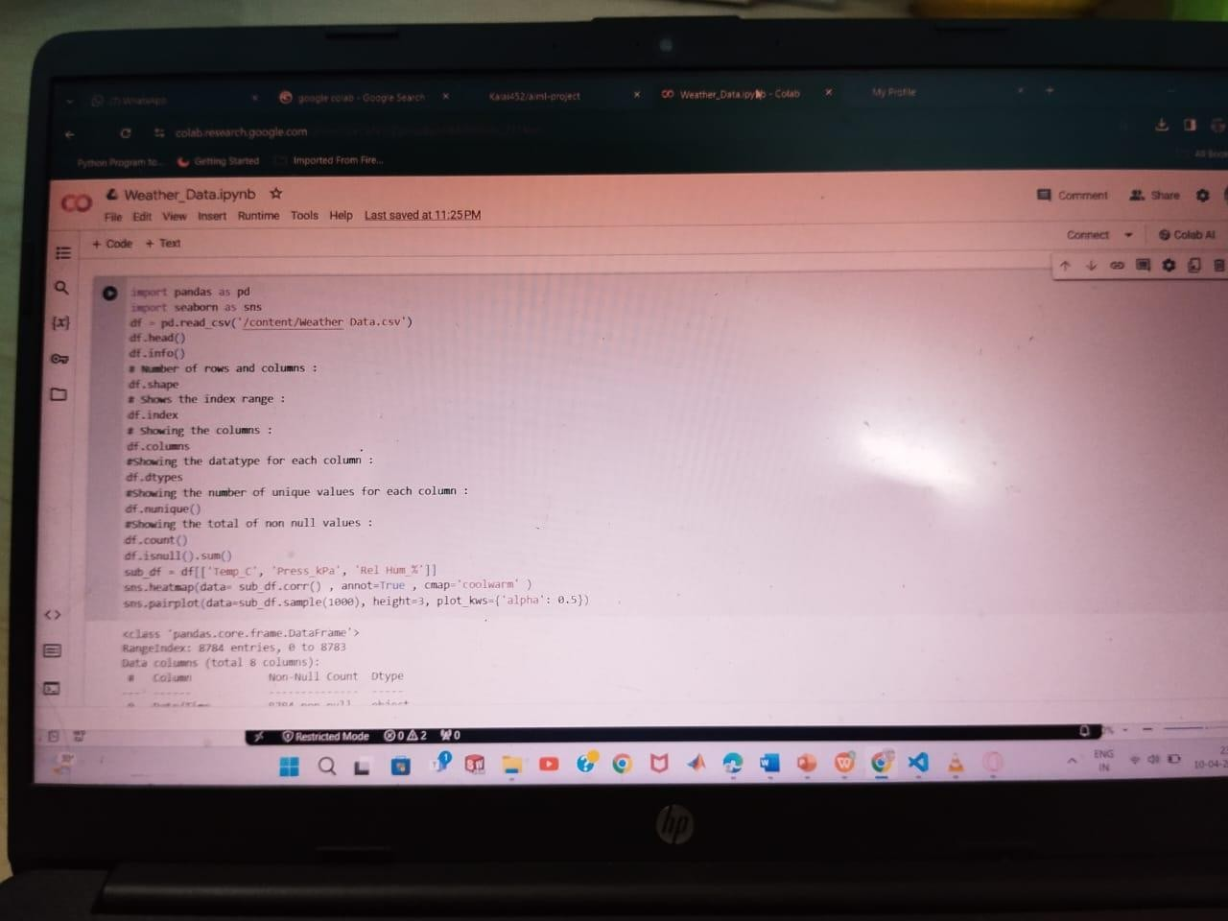**CHAPTER 4 PROJECT OUTCOME**

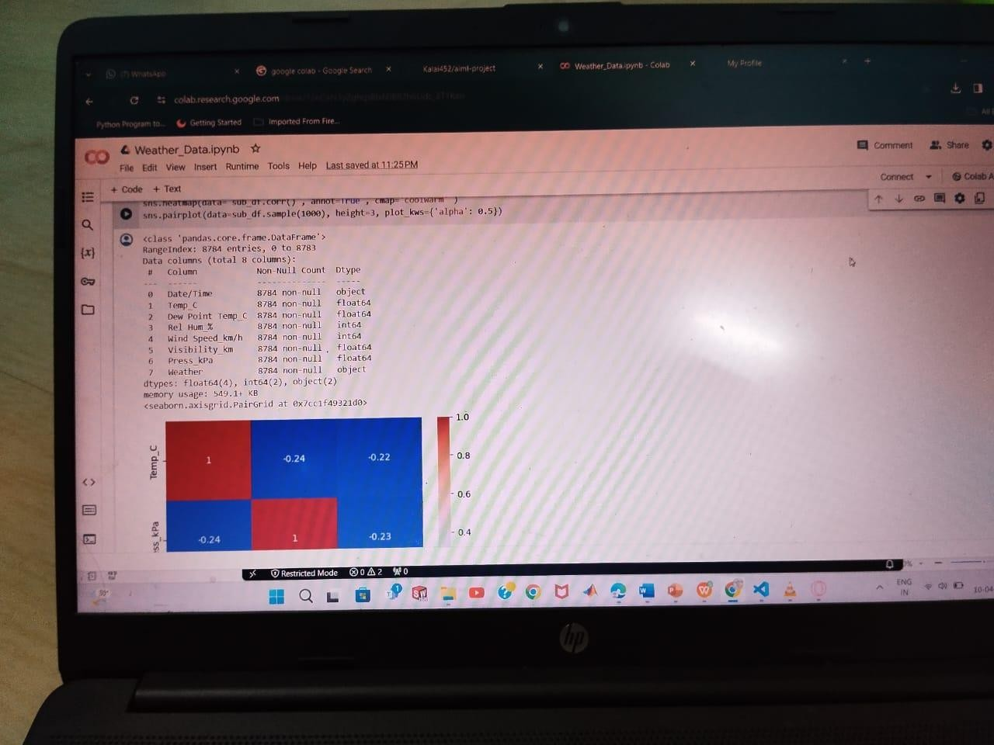

**CONCLUSION**

The suggested platform enables to integrate already available observational, model-forecast and multispectral satellite images and use these data sources for studies and analyzes in a web-based visualization environment. The interactive comparison charts for 2m air temperature allows to visually analyze and gather the information about model accuracy. It enables to adjust the forecasting results with additional methods by implementing statistical analyzes and provides a fairly high result in cases where the model’s sensitivity is low. It is planned to improve the functionality of the platform by adding new visualization tools of various formats, such as to analyze and compare other near-surface atmospheric elements. Different nowcasting methodologies based on artificial intelligence and the utilization of satellite imagery will be implemented for the development of a hazardous hydro- meteorological phenomena alarm system. The extended platform will be integrated with the available cloud services by providing access to the required specialized climatic data. The ultimate goal is to develop an integrated web-based service, which can be used by AHMS for operational weather forecasting and for data analytics for scientific studies.

**FUTURE SCOPE**

* 1. Real-time Visualization: As technology continues to advance, real- time visualization of weather data will become more sophisticated and accessible. This will enable users to monitor and respond to rapidly changing weather conditions with greater accuracy and efficiency, particularly in scenarios such as disaster management and emergency response.
  2. Predictive Visualization: Integrating predictive modeling techniques with weather data visualization can provide forecasts with higher precision and longer lead times. This includes not only traditional weather forecasting but also predictive analytics for climate change impacts, enabling stakeholders to anticipate and adapt to future weather patterns and extreme events.

**REFERENCES**

* + - [**https://www.researchgate.net/publication/325078800_**](https://www.researchgate.net/publication/325078800_) **Weather_Data_Visualization_and_Analytical_Platform**

**CODE**

**Please Provide Code through Git Hub Repo**

[**https://github.com/jagan06093/Jagan.git**](https://github.com/jagan06093/Jagan.git)